SERVING FOOD AND BEVERAGE UNIT:10

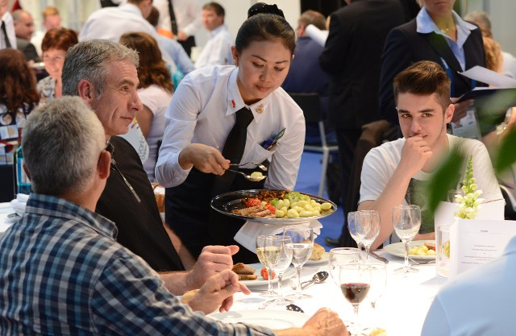

**School: Thaajuddeen**

**Name: Hussain Maain**

**Class: 10-btec**

**Index: 10603**

**The different meal occasions that hospitality organisations cater for (P1)**

* Anniversaries
* private events
* Dinner
* a new year
* family get-together
* a tea parties
* Weddings
* business activities
* Children's events
* romantic dinners
* Mom's Day
* Fireworks night
* Picnic
* Halloween

**The factors that influence the use of different food and beverage service styles in different hospitality businesses (P2)**

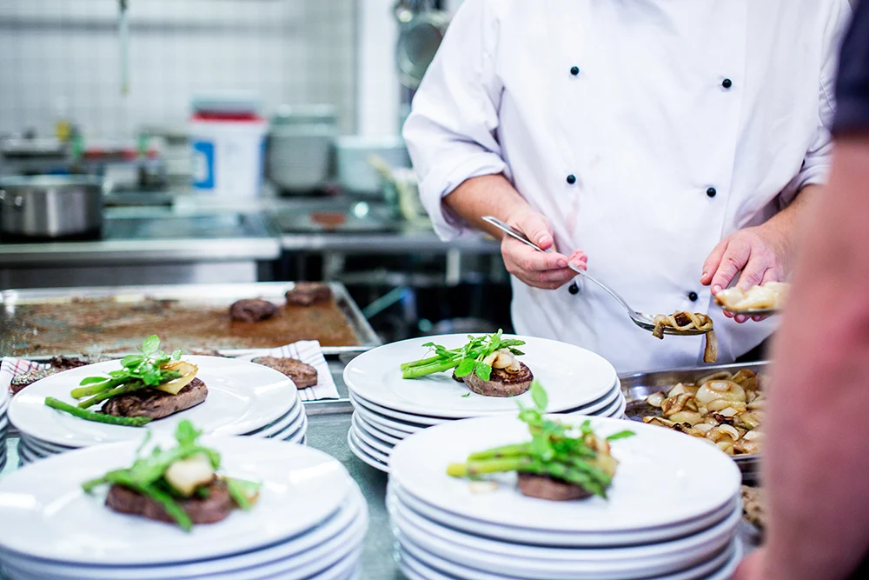

Food:

* Establishment type
* Location of the business
* Availability of service time
* Service area is offered
* meals that will be served

Beverage:

* Type of beverage
* types of clients
* service apparatus
* Period of service
* Place of the service

**Professional, safe and hygienic practices that should be followed when preparing a food and beverage service area (P3)**

**Professional:**

* Allocating servers to stations
* Gathering and polishing tablecloths
* All cutlery, glassware, and dishes need to be polished.

**Safe:**

* Avoid wearing loose jewelry. Eliminate wrist jewelry.
* When suffering from a cold, a cough, or any other contagious illness, avoid working.
* Never use tobacco products or smoke while working.

**Hygienic:**

* Instead of just using running water to wash your hands, use a little soap and warm water.
* Utilize coloured chopping boards and knives, store raw and cooked foods apart, and prevent cross contamination.
* Never sneeze or cough near food, or in areas where food is being prepared or kept.

**Professional, safe and hygienic working practices when serving customers (P6)**

**Professional:**

* Learn how to keep them occupied and without making them wait too long.
* When addressing or conversing with clients, try to be as friendly and welcoming as you can.
* Be sure to be familiar with the specials and menu so you can explain meals to customers as necessary.

**Safe:**

* Avoid using hot dishes, foods, or beverages to reduce the chance of burns.
* Wear the right clothing and personal protection gear for the task.
* Stay away from touching food surfaces.

**Hygienic:**

* Ensure that the table, benches, and chairs are all thoroughly cleaned.
* Hold plates at the edges or by the bottom.
* Keep your fingernails tidy and short.

**The techniques which can be used to assess the success of food and beverage service (P8)**

* **E**xamine how quickly your tables are turning over while still providing excellent service to determine how efficiently you are seating people.
* Compare your average staff hourly cost to the total revenue divided by the total labour hours.
* In order to create a menu price that provides for a healthy profit margin, consider the profitability of the recipes.
* Get the measure of employ turnover rate to evaluate affect your current and future customer base.
* Get the measure of historical sales to tracks how a restaurant is doing over time.